

**COLÉGIO LEONARDO DA VINCI**

**Aluno (a): _____________________________________________**

**Professor (a): Jullyanna Data: ___/____/____ Série: 5º ano**

**ATIVIDADES DE REFORÇO – SEMANA 1**



|  |
| --- |
| LÍNGUA PORTUGUESA |

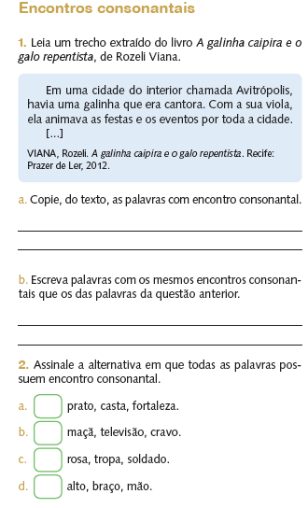

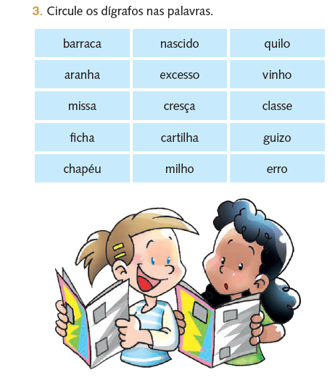

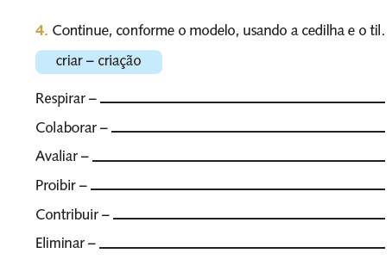

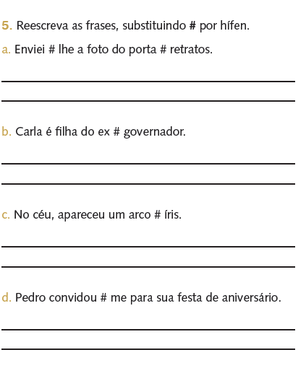

|  |
| --- |
| MATEMÁTICA |

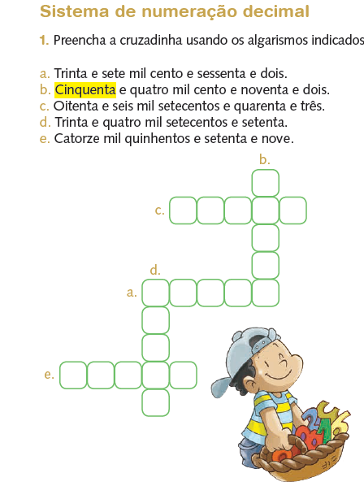

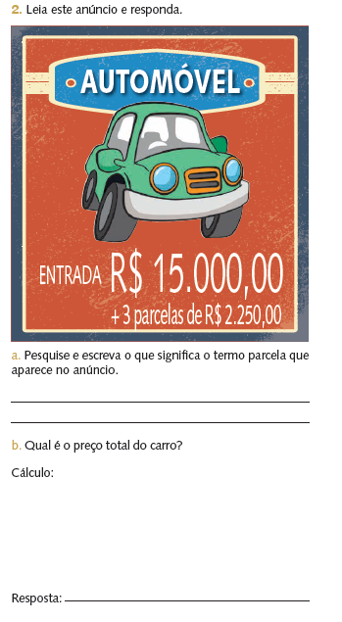

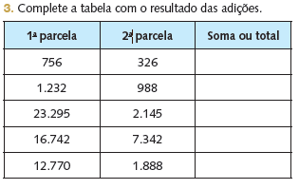

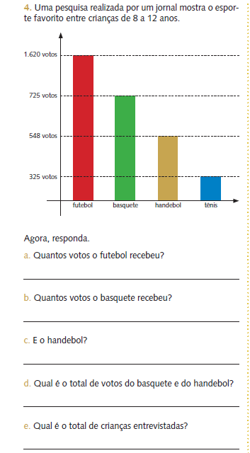

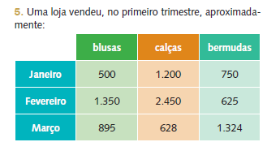

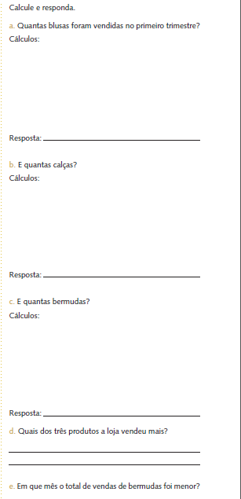

|  |
| --- |
| CIÊNCIAS |

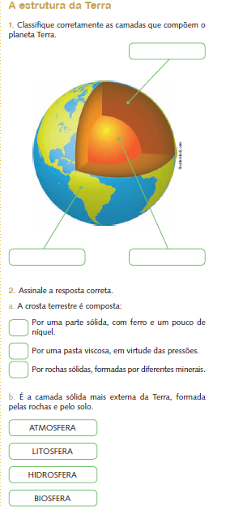

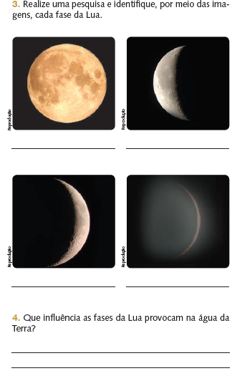

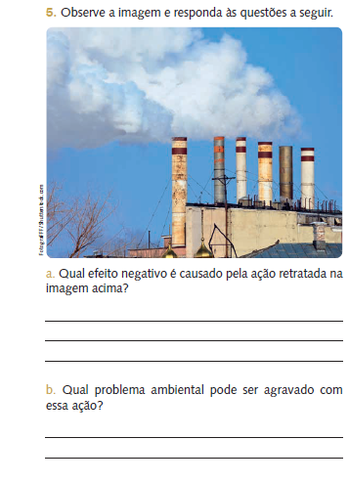

|  |
| --- |
| GEOGRAFIA |

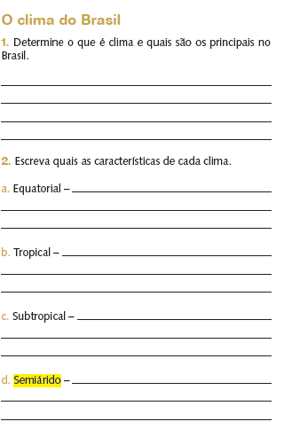

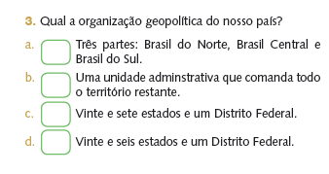

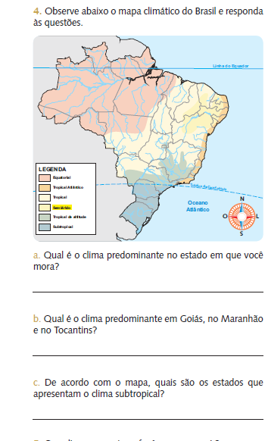

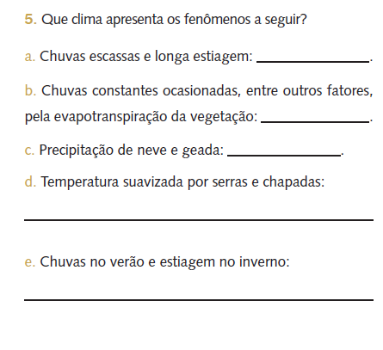

|  |
| --- |
| HISTÓRIA |

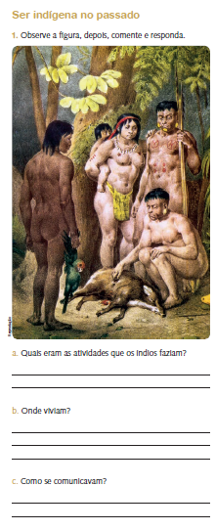

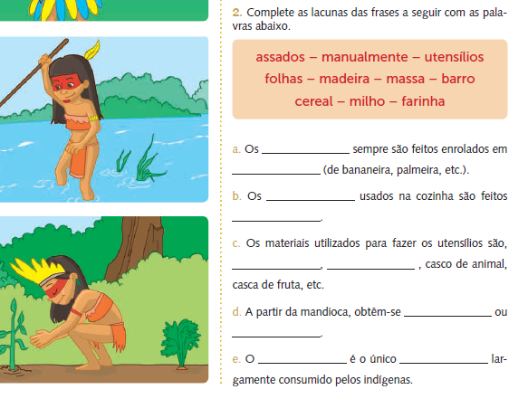

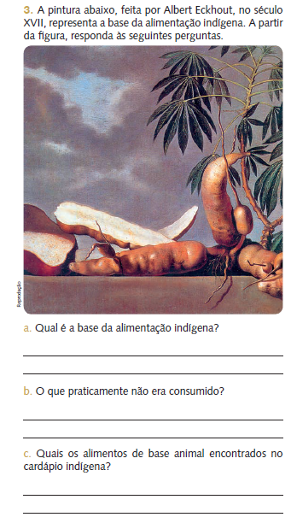

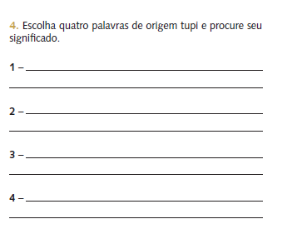

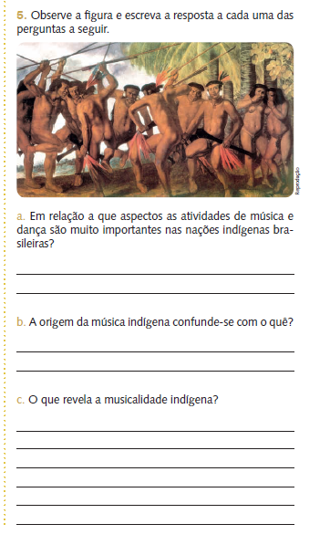

|  |
| --- |
| LÍNGUA INGLESA |

1. Observe a imagem e em seguida marque a alternativa correspondente.

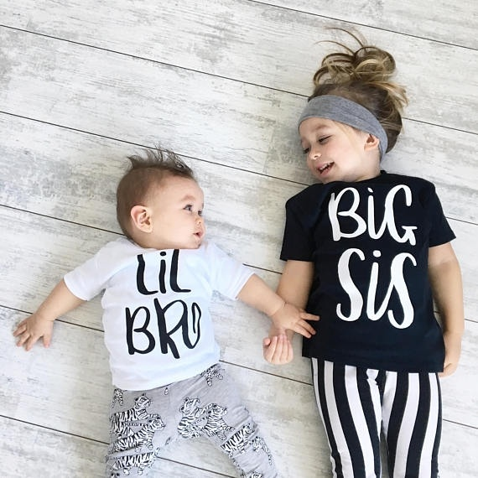

1. Son and daughter
2. Uncle and aunt
3. Brother and sister
4. Nephew and niece
5. Assinale a alternativa que traduz o termo em destaque.

Chico and Severina are my **grandparents**.

1. Pais
2. Avós
3. Tios
4. Primo
5. Marque as alternativas corretas.
6. Usamos **his** para:

( ) boy; man ( ) girl; woman

1. Usamos **her** para:

( ) boy; man ( ) girl; woman

1. Responda as perguntas abaixo utilizando os nomes entre parênteses.
2. What is her name? (Laura)

____________________________________________________________________________________________________________________________________________

1. What is his name? (Lucas)

____________________________________________________________________________________________________________________________________________

1. Complete com **his** ou **her**.
2. ______ name is Bia.
3. ______ name is Paulo.
4. ______ name is Gustavo
5. ______ name is Cristina.

|  |
| --- |
| ARTE |

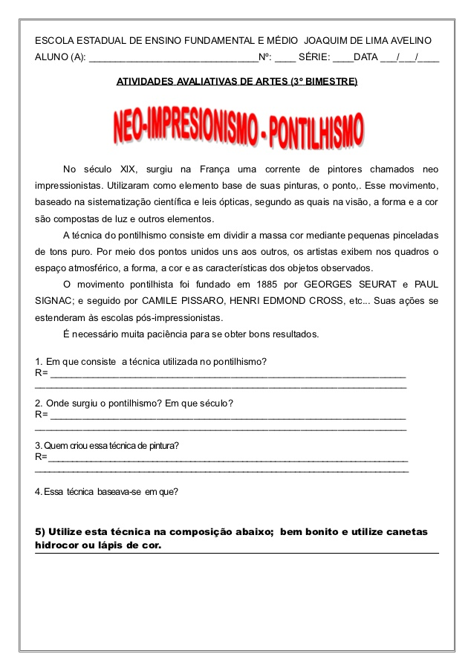





|  |
| --- |
| ÉTICA E CIDADANIA |

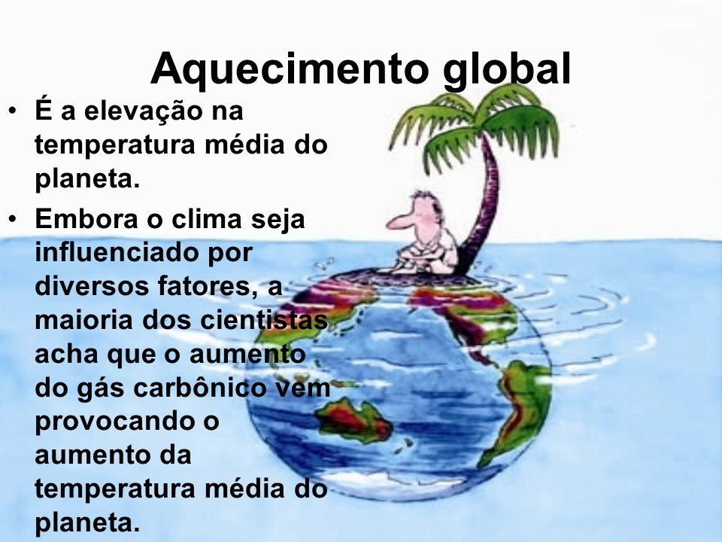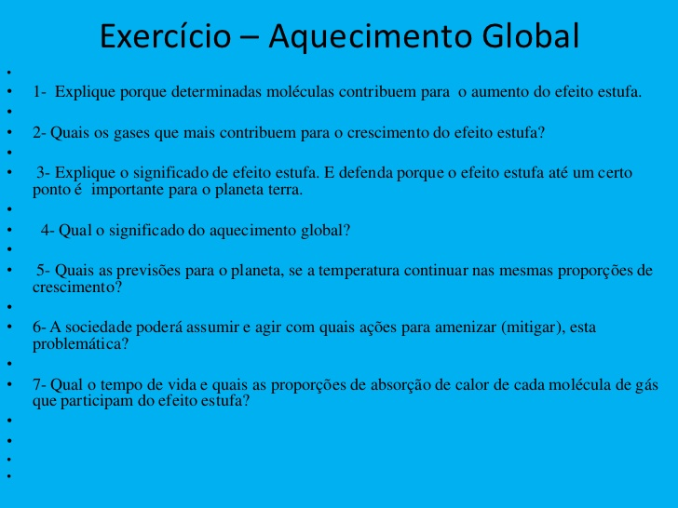

|  |
| --- |
| EMPREENDEDORISMO |

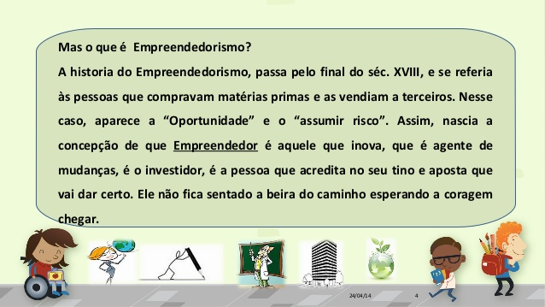

**Responda as questões a seguir:**

